REMAINING DB LAB TASKS (15-17)

21K-3153

Task 15:

Doesn’t work because table can only have one primary key

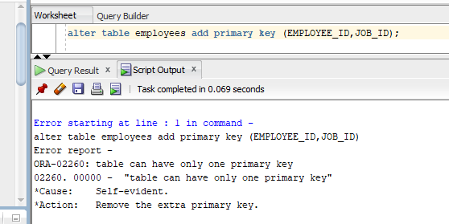

Task 16:

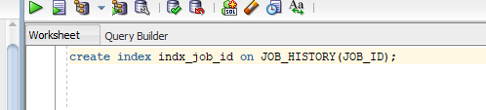

Task 17:

